**VIRTUAL STYLIST APP**

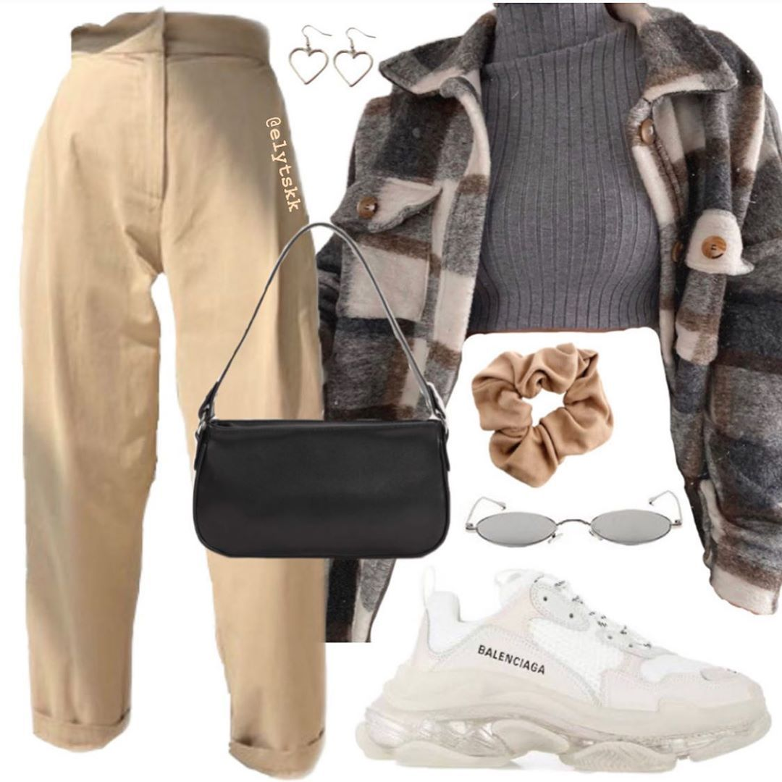

**1.BUSINESS MODEL**

There can be various models implemented to generate revenue.

1. The most simple and common one would be a *subscription model* where customers must pay a monthly fee to make use of the app and its features. It can be done so that the most basics services are free and as the recommendation and higher styling services require a subscription. The subscription pack could include rare fashion pieces, insights into upcoming trends, one on one interaction with actual stylists or even try on services.
2. Most apps use *advertisements* to generate money. Collaborating with fashion brands and influencers for sponsored content and advertising within the virtual stylist app.
3. *In-app purchases* for limited edition items and being able to buy the recommended outfit for an occasion directly from the app, etc.
4. Partner with fashion retailers and e-commerce platforms to recommend clothing items to users. Earn a *commission* for each successful sale made through the virtual stylist's platform.

An effective business model would integrate all the above in the right combination to generate good revenue. User satisfaction also plays a big role in the success of the app.

**2.FINANCIAL EQUATION:**

Creating a financial equation for the Virtual Stylist App involves estimating revenue and cost components. Below is a simplified financial equation for the app:

**Total Revenue = (Subscription Revenue + Affiliate Marketing Revenue + In-App Advertising Revenue + Data Licensing Revenue)**

* Subscription Revenue: This includes income generated from premium subscription plans offered to users who want enhanced features and early access to trends. The subscription fee can be denoted as "S."
* Affiliate Marketing Revenue: This revenue is earned through commissions on sales made through affiliate links to partner retailers. The commission rate can be represented as "C" (as a percentage of sales), and the total sales generated through affiliate links as "A."
* In-App Advertising Revenue: This income comes from displaying relevant ads from fashion brands within the app. The total ad impressions can be represented as "I," and the earnings per impression can be represented as "E."
* Data Licensing Revenue: This revenue is generated by analyzing user data and providing fashion insights to clothing brands and retailers. The total revenue from data licensing can be represented as "D."

**Total Cost = (App Development Cost + AI and AR Technology Cost + Marketing and Promotion Cost + Staffing Cost + Data Security Cost)**

App Development Cost includes expenses related to the ongoing development and maintenance of the app, including salaries for developers, infrastructure costs, and software licenses. It can be represented as "AD."

AI and AR Technology are expenses related to AI algorithms, augmented reality capabilities, and technology licenses. It can be represented as "AT."

Marketing and Promotion Cost covers the budget allocated for marketing campaigns, partnerships, and advertising. It can be represented as "MC."

Staffing Cost includes salaries and benefits for fashion experts, developers, customer support staff, and other employees. It can be represented as "SC."

Data Security Cost expenses associated with maintaining robust data security measures to protect user information. It can be represented as "DS."

**Profit (or Loss) = Total Revenue - Total Cost**

**Profit = (S + (C * A) + (I * E) + D) - (AD + AT + MC + SC + DS)**